**WEB APPLICATION DEVELOPMENT LAB**

**06-02-2025**

Eshwar Deshmukh Chavan

HU22CSEN0100999

**1.Display XML data using XSLT**

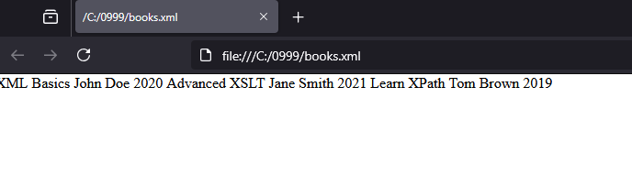

Books.xml code:

<?xml version="1.0" encoding="UTF-8"?>

<?xml-stylesheet type="text/xsl" href="books.xsl"?>

<library>

<book>

<title>XML Basics</title>

<author>John Doe</author>

<year>2020</year>

</book>

<book>

<title>Advanced XSLT</title>

<author>Jane Smith</author>

<year>2021</year>

</book>

<book>

<title>Learn XPath</title>

<author>Tom Brown</author>

<year>2019</year>

</book>

</library>

Books.xsl code:

<?xml version="1.0" encoding="UTF-8"?>

<xsl:stylesheet xmlns:xsl="http://www.w3.org/1999/XSL/Transform" version="1.0">

<xsl:template match="/library">

<html>

<head>

<title>Book List</title>

</head>

<body>

<h1>Book List</h1>

<table border="1">

<tr>

<th>Title</th>

<th>Author</th>

<th>Year</th>

</tr>

<xsl:for-each select="book">

<tr>

<td><xsl:value-of select="title" /></td>

<td><xsl:value-of select="author" /></td>

<td><xsl:value-of select="year" /></td>

</tr>

</xsl:for-each>

</table>

</body>

</html>

</xsl:template>

</xsl:stylesheet>

**2.Write JavaScript using regular expression search() and replace().**

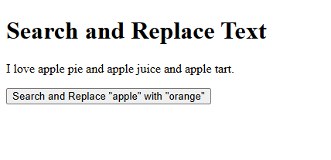

After Clicking Button:

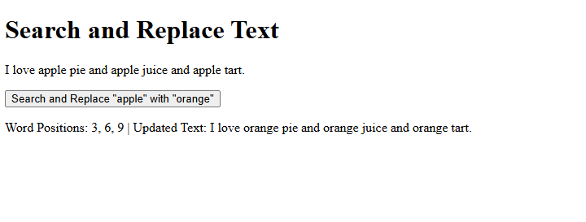Code:

<!DOCTYPE html>

<html lang="en">

<head>

<meta charset="UTF-8">

<meta name="viewport" content="width=device-width, initial-scale=1.0">

<title>Search and Replace Example</title>

</head>

<body>

<h1>Search and Replace Text</h1>

<p id="text">I love apple pie and apple juice and apple tart.</p>

<button onclick="searchAndReplace()">Search and Replace "apple" with "orange"</button>

<p id="result"></p>

<script>

function searchAndReplace() {

let text = document.getElementById("text").textContent;

let words = text.split(" ");

let positions = [];

for (let i = 0; i < words.length; i++) {

if (words[i].toLowerCase() === "apple") {

positions.push(i + 1);

}

}

if (positions.length > 0) {

let replacedText = text.replace(/apple/g, "orange");

document.getElementById("result").textContent = "Word Positions: " + positions.join(", ") + " | Updated Text: " + replacedText;

} else {

document.getElementById("result").textContent = "The word 'apple' was not found in the text.";

}

}

</script>

</body>

</html>